Internet Security - Lab 5 Report

# Task 1: Frequency Analysis Against Monoalphabetic Substitution Cipher

Running the cyphertext through the letter frequency tool at: <http://www.richkni.co.uk/php/crypta/freq.php> we get a count of the words:

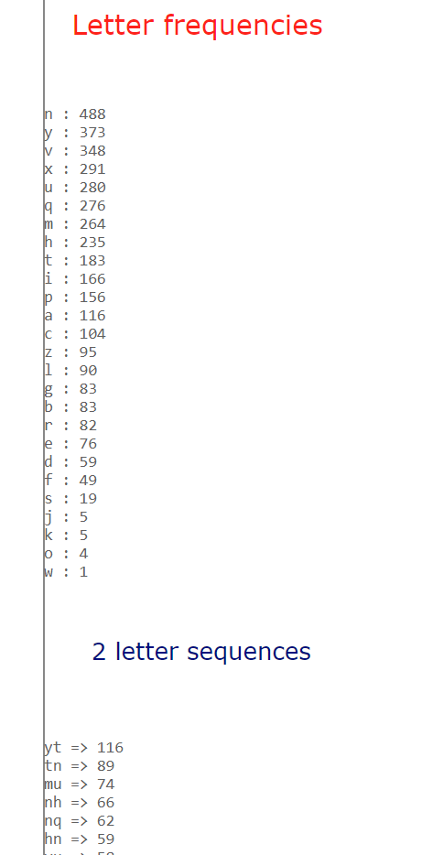

From Wikipedia.com we see the most popular Bigrams in the English Language:

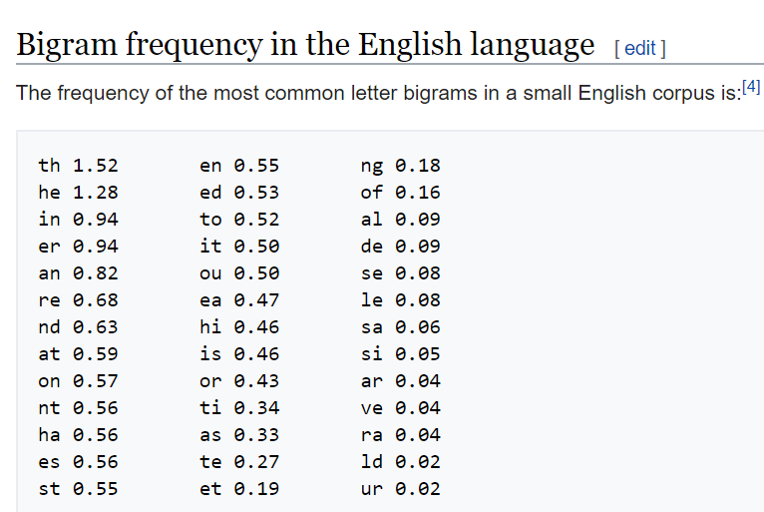

Using the tool at <https://www.guballa.de/substitution-solver> suggest trying the following decryption key:

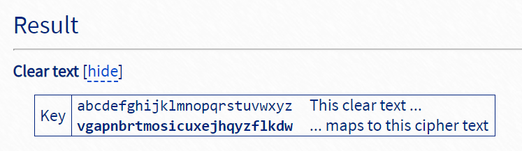

We use the translate command to solve the cipher:

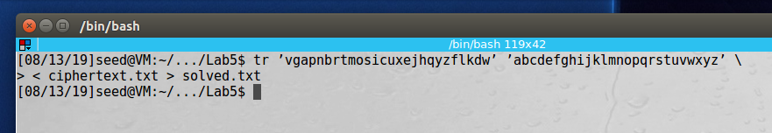

Now we can see our deciphered text:



**Observation**: In this task we were presented with a cipher text that was using a simple substitution cipher. We were able to use a tool to do a letter count to find out which letters were found the most often in the text and compare that to the letters found most often in the English language. One method to solve would be with trial and error substituting in one letter at a time until the message makes sense. We also used a web tool that suggested a substitution key that we should try based one the method previously discussed. We transformed the cipher text using the key and were able to read the message.

**Explanation**: Simple substitution ciphers are easy to break by analyzing the frequency of letters in the cipher text to the know letter frequency of a specific language. Messages using this type of encryption are trivial to crack.

# Task 2: Encryption using Different Ciphers and Modes

First, we show the plain text file that we are going to use for encryption:

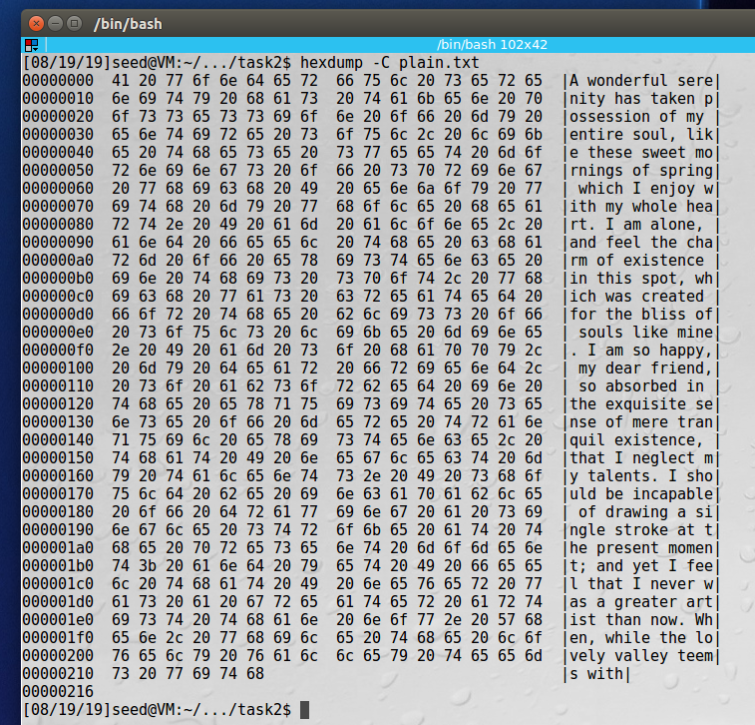

Here we issue the command to encrypt the text using **128-bit AES encryption using ECB** mode:

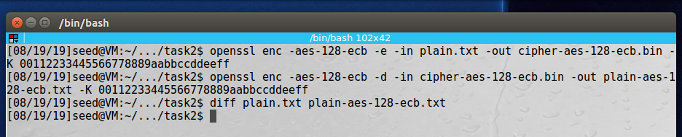

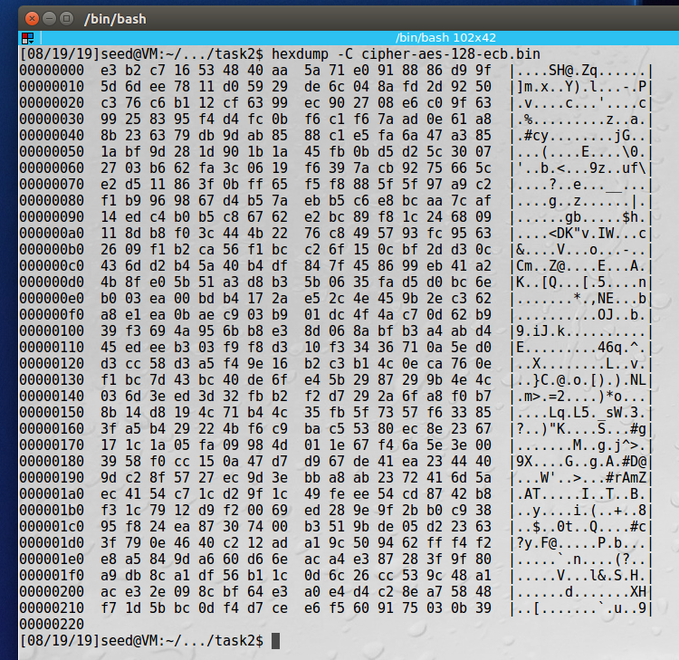

Next we use **128-bit AES encryption in CBC** mode:

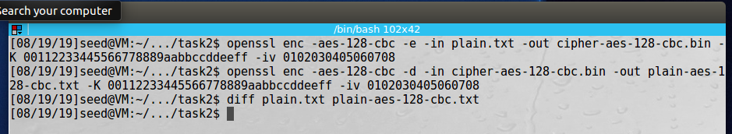

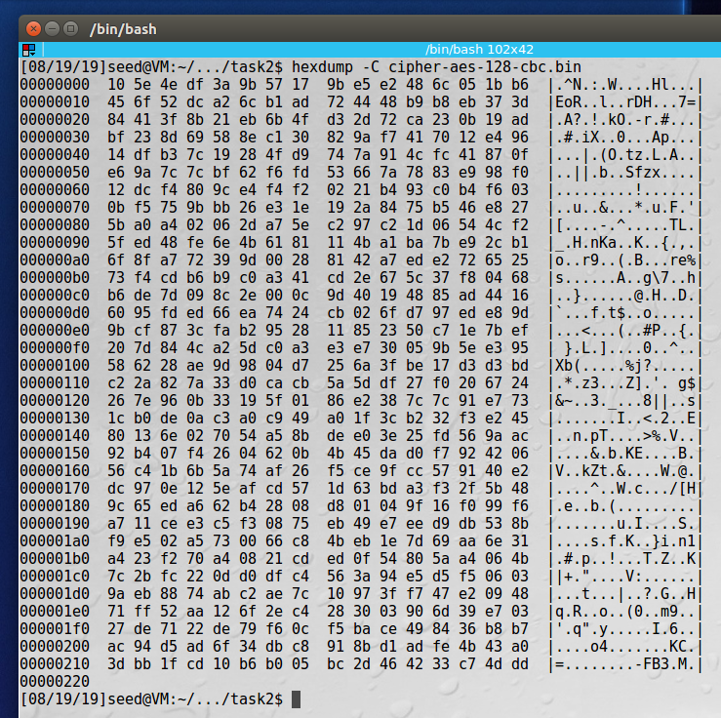

Finally, we use **128-bit AES encryption in OFB** mode:

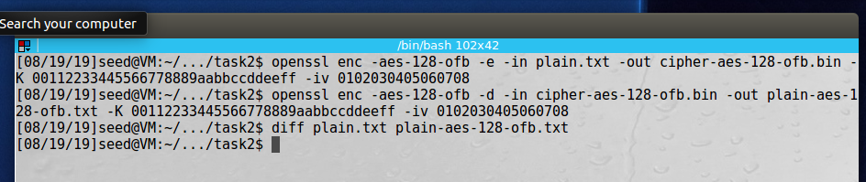

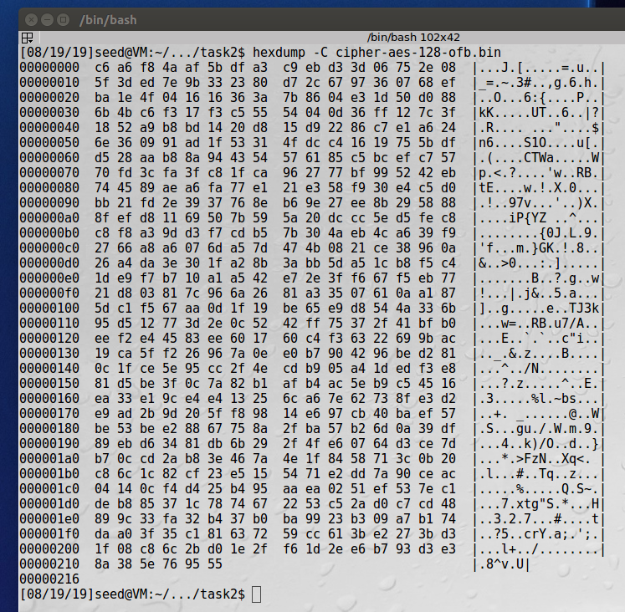

We see all the files that we created, interestingly, the 128-bit AES in OFB was encrypted file that was the same file size as the plain text version.

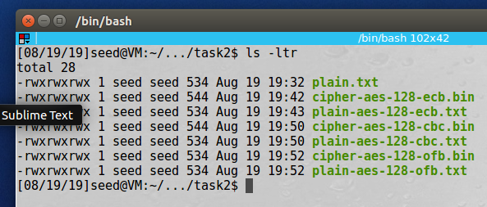

**Observation**: In this task we encrypted files using the built in openssl encryption/decryption program. Then we decrypted the files and compared them to the original. And saw that the files went through the encryption and decryption process and matched the original file exactly. We used the Linux diff command to demonstrate this. We used 3 different encryption modes, 128-bit AES in ECB, CBC, and OFB Modes. It was interesting to note that only the OFB cipher text was the same file size as the original plain text.

**Explanation**: The Linux openssl program allows us to easily encrypt and decrypt files using many different encryption algorithms and modes.

# Task 3: Encryption Mode – ECB vs. CBC

Original Image that we are going to use for encryption:

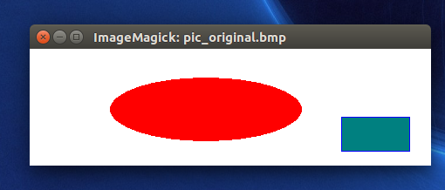

First, we save off the image header:

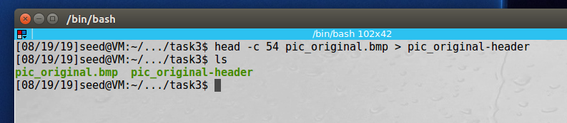

Then we encrypt the image and add back the image header:

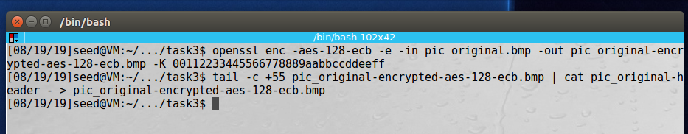

We can see the AES-ECB mode image, wasn’t encrypted very well:

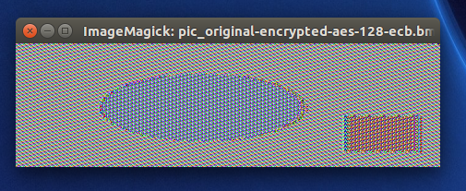

Now we encrypt using the AEC-CBC mode and add the header:

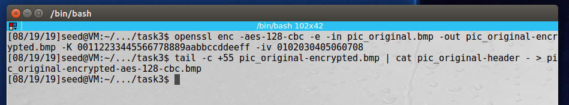

And we can see that using AES-CBC worked much better:

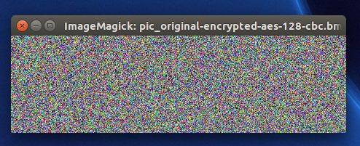

This is the image that we are going to use to run the test again:



Now we save off the header, encrypt using AES-ECB and add the header back:

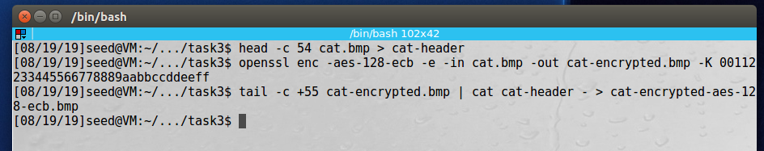

Looking at our encrypted image we can still see that it’s a cat:

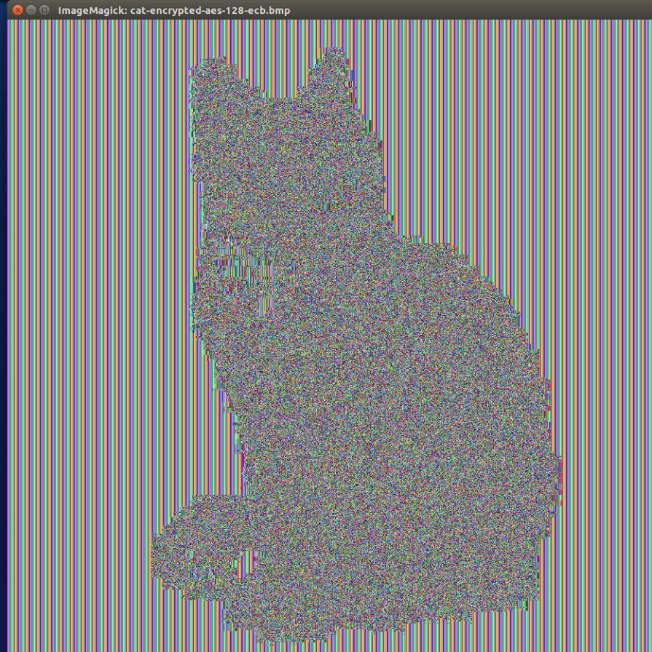

Now we encrypt it using the AES-CBC Mode:

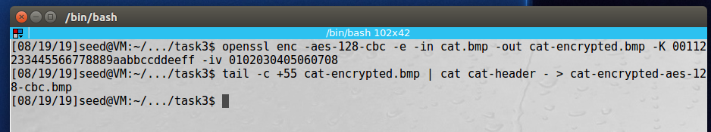

And see that it did a much better job this time:

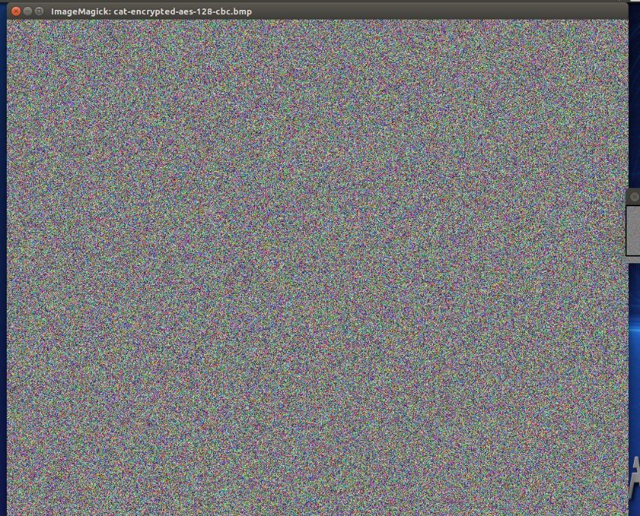

**Observation**: In this task we encrypted bitmap images using two different modes of AES, ECB and CBC. The first thing we did was save off the header information which is contained in the first 54 bits of file. Then we encrypted the file using 128-bit AES in ECB and CBC modes. Next we added to the header back to the encrypted files and tried to view them. In the ECB mode we were able to still see the outline of the objects in the original image, loosing only some detail and color information. In CBC mode the image was completely obfuscated. We repeated this experiment with our own image files achieving the same results.

**Explanation**: In this task we notice that AES in CBC mode was a better choice for encrypting bitmap files since after adding back the header information we were unable to see what was in the image.

# Task 5: Error Propagation – Corrupted Cipher Text

We start with a plain text file with size of 1332 bytes:

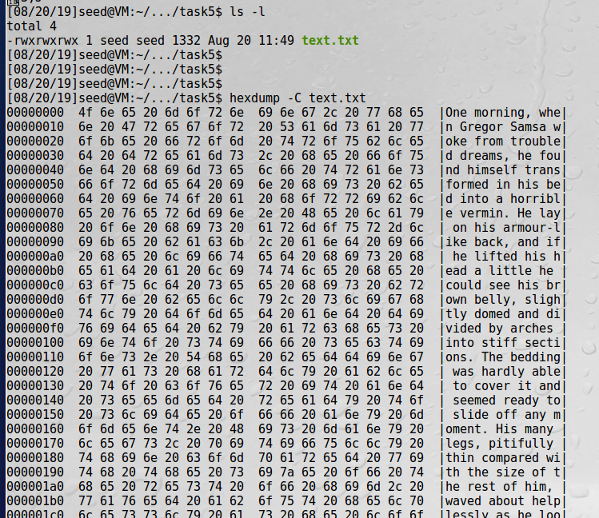

Next we are going to encrypt the file using 128-bit AES in ECB mode. My assumption is that after we encrypt and corrupt one of the bytes that only that one byte will be corrupted, and the rest of the document will decrypt normally:

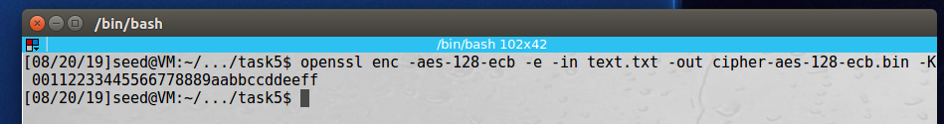

Next we’ll make a copy of our encrypted file where we are going to corrupt one byte:

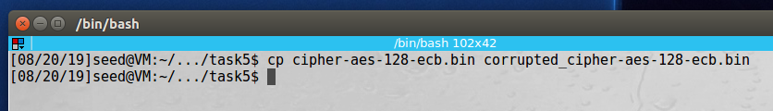

Before the corruption, you can see the 55th byte is selected, with an original value of 0xED:

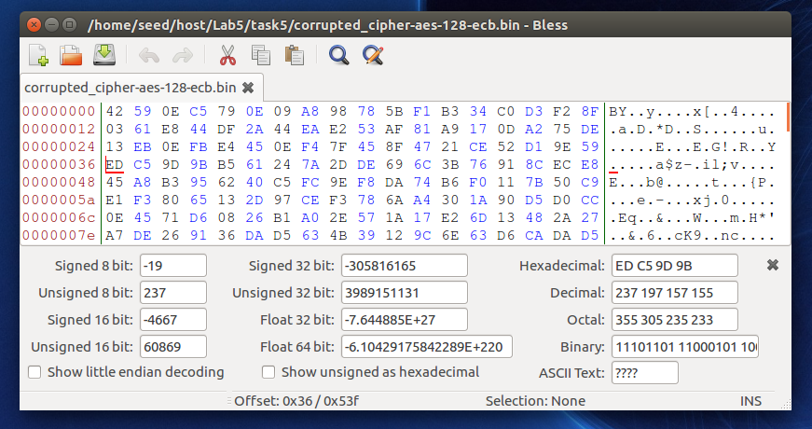

And we change it to 0x24:

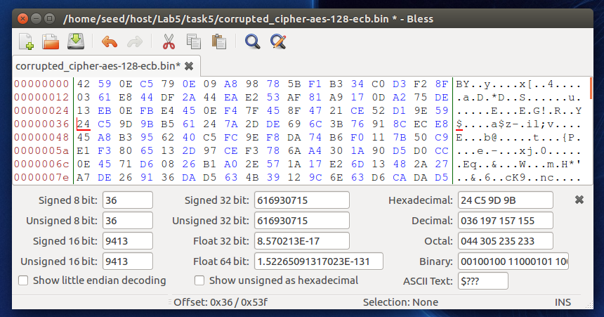

Now we decrypt the file that we just corrupted:

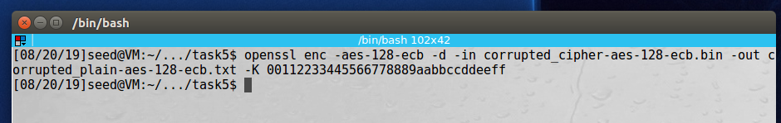

Looking at the decrypted **128-bit AES in ECB** mode, we see that the entire block that contained the corrupted byte was corrupted but all the blocks before and after were unchanged:

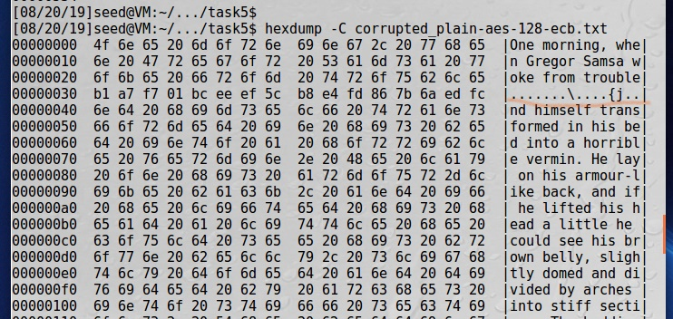

Running the experiment in different modes, only showing the resulting output for each:

Using **128-bit AES in CBC** mode the entire block with the corrupted byte was incorrectly decrypted as well as one byte in the next block:

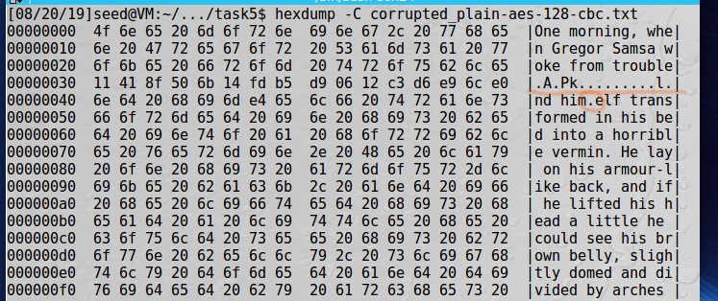

Again, using **128-bit AES in CFB** mode the byte that we changed is incorrectly displayed, but the rest of that block is unchanged, however, the entire following block is incorrect:

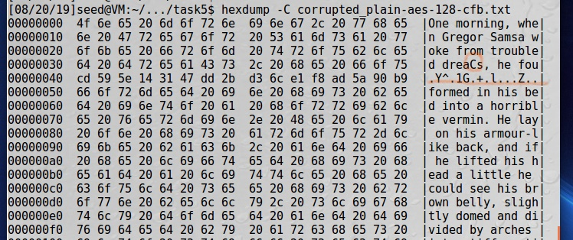

Using **128-bit AES in OFB** mode only the byte that we corrupted was changed, the rest of the block and other blocks are unchanged:

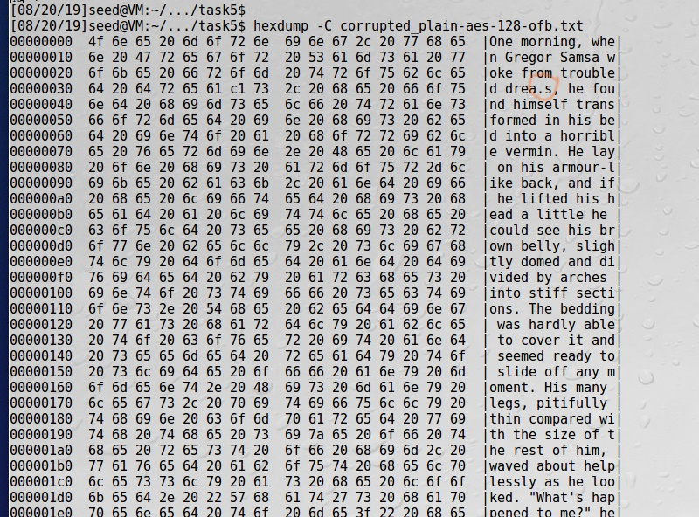

**Observation**: This task has us encrypt data using four different AES block cipher modes, ECB, CBC, CFB, and OFB. After we encrypt the file, we change one byte of the encrypted file and then decrypt to see how our error has propagated. We changed the 55th byte to ‘0x24’ in all the experiments and then decrypted the files to examine how the byte change affected the file. The results were different in all the modes. In ECB mode the entire block that contained the corrupted byte was lost. In CBC mode, the entire block plus one byte in the following block was lost. Using CFB, only the byte that we changed was lost in the block, but the entire following block was lost. And finally using OFB, only the byte that we changed was lost.

**Explanation**: Data corruption errors propagate in various modes of AES encryption differently. In OFB mode it’s only the corrupted byte that is lost, in other modes the entire block is lost, or the proceeding for following blocks are affected as well. The differences are due to how XOR and Initialization Vectors are implemented in the different modes.